

Semantic Web and Knowledge Engineering
Report

1.TITLE

PHARMACOLOGY
DRUG
ONTOLOGY

2. Abstract

Pharmacology Drug ontology is designed to examine the person suffering from disease which is diagnosed by its symptoms according to the gender and age. Furthermore, symptoms are treated by the drug/medicine which contains prominent information like drug dose, drug content, its manufacturer and drug type which is predominantly used by the Pharmacies for its sell. Drugs are reviewed though the rating process by different patients or pharmacies according to its demand. The role of pharmacology is to assimilate the cause for this amelioration are proceeding, authorizing to widen the outshining drug (Arbabi, 2018). For this purpose, an ontology of pharmacology is developed as an artificial intelligence system. Pharmacologist is a scientist that researches innovative drugs to link this information through ontology. Therefore, this medical-related pharmacology topic was implemented for researchers and biomedical students.
Ontology development is a convoluted job, though Drug ontologies could enable pharmaceutical specialists to fatigue the over-burden of data and speed the pace of medication revelation, profiting the business and patients likewise. Drug-Disease relations, explicitly tranquilize sign relations, are a prime possibility for portrayal in ontologies. (Sharp, 2017).

Pharmacology Drug Ontology has been emerging steadily since 2019.there is now a substantial purport division and equities that will be unchangeable, in addition to prudent modification to the report for implementing feedback and emerging better practice (Brickley, 2014). Though this ontology has cleared its aim for providing congenial source for researchers and biomedical students, regarding specific drugs according to the symptoms.

Keywords: Pharmacology, Disease, Symptoms, Drug/Medicine, Pharmacy sale, Reviews.

3. Table of Contents

1.TITLE 2
2. Abstract 3
3. Table of Contents 4
4. Introduction 5
4.1 Project Plan 6
5. Related Work 7
5.1 Schema of Pharmacology System: 9
6. Ontology Documentation 12
6.1 Methodology for Pharmacology ontology development 12
6.2 Classes 14
6.3 Object Properties 14
6.4 Data Properties: 16
6.5 Individual means value of ontology: 18
6.6 Pharmacology Drug Ontology Class diagram among other classes: 19
7. Example of Usage 23
7.1 SPARQL QUERIES 23
8.Evaluation of Implemented Approach 30
8.1 DL queries 30
8.2 SWRL Functional Rules 37
9.Conculsion 41
10.Future Work 41
References 42

4. Introduction

The survey of drug, their inception, their essentiality and their premises. Pharmacology is the investigation of the body's response to drugs. (Melissa Conrad Stöppler, 2020) Pharmacology means to cogitate pharmaceutical along with their jounce on living frameworks. It can be discovered as pharmacology is familiar and is spreading like a wild fire throughout the world. Pharmacology is additionally answerable for morphine, caffeine beverages, and anti-toxins. Research about the indeed befalling the generality along with the drug too (society, 2020). Pharmacology is designed to develop an effective and value drug for the society use. For this purpose, Researcher have developed an ontology of pharmacology as an artificial intelligence system. Because A pharmacologist is a scientist that researches innovative drugs. So, the Researcher wants to link this information through ontology. Therefore, the Researcher has selected this medical-related pharmacology topic which will help the biomedical students and the pharmacies to extract information about plethora of diseases, symptoms and its drugs.

During the past years, Semantic Web appeared as latest propagation of this world wide web with upgraded technologies including cutting edge innovation techniques and research commitments. It has changed the utilisation of data by permitting clients to catch and distribute machine-justifiable information and upsurging the strategies Ontologies boons the illustration of a definite demesne like pharmacology ontology and fugitive extensive electric conventions. Even though the engirding of anthologies and practice of intellections has subsisted a consequential component of semantics, pharmacology ontology as substitutive demesne of delving as search of the semantic web information, connecting and utilisation of widely spread information throughout the network, and the consequent practice of these anthologies in developing applications for semantics which has turned fruitful recently. Moreover, the kind of research pledge on which we will be concentrating is perusing connection with RDF information. Semantic web exponents the technique about the connecting information to distribute organized data on the web. The vast majority of the connected information is accessible as browsable RDF information which is assembled utilizing significantly increases that characterize declarations as subject(s)-predicate(p)-object(o). These triples can be classified by arranging the three sections into independent column. (Chittella, 2019).
This ontology is all about the Pharmacology Drugs which is constructed in .owl format using Protégé tool. Firstly, Researcher has developed Classes in Pharmacology ontology. In this Active Ontology URL is https://www.biologyonline.com/dictionary/pharmacology which have taken Drug, Disease, Symptom, Pharmacy, Reviews and Subclass Content, Dose, Drug Manufacturer, Drug Type of Drug class.

4.1 Project Plan
Pharmacology ontology will cover core systems such as Drug, Disease, Symptom. The drug includes Drug content, dose, drug type, a drug manufacturer.
Firstly, Researcher have roughly designed the information about Pharmacology ontology related schema. In this schema, the Researcher has introduced the specific entity that is involved in entity-relationship. While the researchers have prepared specific Entity Relationship Diagram (ERD) for creating Pharmacology ontology. An E-R map (Entity Relationship Drawing - ER Diagram in DBMS, 2020) articulations the connection between building blocks. A part and parcel asses are an assortment of equivalent partitions and these fragments can have traits. As far as DBMS, an element is a table or property of a table in the database, so by indicating connections among tables and their properties, E-R delineate reveals the absolute legitimate edifice of a database in pharmacology ontology.
Secondly, Protégé is less costly as compared to the other tools. It is an open-source ontology tool and a knowledge management framework. Protégé gives a realistic tool to characterize ontologies. Protégé is a system for which recommend different undertakings modules. This application is written in Protégé. (Protege, 2020)
Lastly, the Researcher has developed this ontology incorporation with distinct SPARQL server queries and Dl queries along with SWRL queries where functions are implemented. It is a stunning extensively helpful ontology and is used in web improvement

5. Related Work
William R. Hogan had revealed “an ontological investigation of drug from the pragmatist point of view, and assessed existing medication wording, ontology, and database ancient rarities from (1) the specialized viewpoint, (2) the viewpoint of pharmacology and clinical science (3) the viewpoint of depiction rationale semantics (in the event that they were accessible in Web Ontology Language or OWL) and (4) the viewpoint of our authenticity-based examination of the space. No current asset was adequate.”
Bona said, “The Drug Ontology (Dr On) is a sectional, extensible ontology of drug products, their elements, and their biological activity created to enable relative usefulness and health services researchers to query National Drug Codes (NDCs)”. (Bona, et al., 2019)
William describes about the pharmacology ontology, as it has mediocre properties and Bona also contributed the talk by explaining that we have to spread ontology so that Researcher working on pharmacology ontology for the first time must have mandatory and pivotal information about the different drug.
The Pharmacology Ontology (OP) is a biomedical ontology planned from lowest to updated logically characterize several rough classes include like Drug/Medicines, Disease, Symptom and Drug Content, Drug type, Drug dose, and its manufacturer observed after medical interventions. Also, there are some relationships mentioned between these classes.
According to Siricharoen “Ontology is a castigation that is part of the knowledge representation arena. The Ontology describes the variety of things that occurs in an application domain. In the computing situation, an ontology is a framework for representing concepts (things, or thoughts about things) and the relationships that exist between those concepts. In an ontology, a specific explanation is associated with each concept and relationship type that is used. Ontology technology is well-thought-out to be extremely fit.” (Siricharoen, 2009)
RDF develops a model for depicting equities and it have properties like traits or qualities. RDF characterizes an asset as an article that is exclusively recognizable by a Uniform Resource Identifier (URI). The equities aligned with other resources are identified by property types, which compares apprise. Property types also express the acquaintance about the qualities related to the assets. In RDF, qualities might be nuclear in nature (content strings, numbers, and so on.) or different assets, which thusly may have their own properties. An assortment of these properties that alludes to a similar asset which is also known as a portrayal. The Resources and the relying portrayals are developed by the RDF which is a syntax-independent model at the centre.

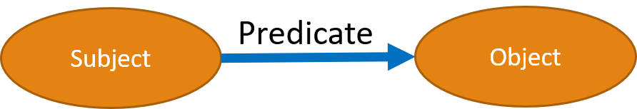
Figure 1. A generic RDF Triple

RDF graph: relationship of triple between disease class and symptom class with is diagnosed by predicate(relation).
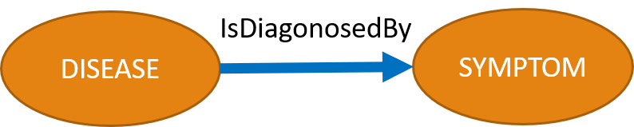
Figure 2. Disease is diagnosed by Symptom (RDF triple)
Resource Description Framework (RDF) and SPARQL are the two pivotal terms in Semantic Web. RDF has true standards of information portrayal on the Semantic Web. The widespread appropriation of this standard can be credited to the way that it has an adaptable model. Because of the boundless reception of Semantic web, an unexpected step increment in the measure of RDF information has been seen. This huge volume of RDF information can't be dealt with by the customary Centralized RDF the board frameworks. Consequently, it comes into the image as requirement for Distributed RDF information the executive frameworks that can appropriate this RDF information on a bunch of hubs. Along with these lines, the bottlenecks of the Centralized RDF frameworks in regards to the volume and proficient questioning can be survived. This paper presents an itemized portrayal and examination of the distinctive Centralized and Distributed RDF information the board frameworks. (Chahal & , 2021)
Furthermore, SPARQL articulated 'sparkle', is the standard analysis query language and contract for Linked Open Data on the web or for semantic figure databases (likewise called RDF triple stores). "SPARQL Protocol and RDF Query Language", empowers clients to question data from databases or any information source that can be mapped to RDF. The SPARQL is planned and embraced by the W3C and enables clients and designers to concentrate on what they might want to know rather than how a database is composed. (What is SPARQL - Semantic Search Query Language – Ontotext, 2020). There are the sample SPARQL queries of Pharma ontology (W3C, 2010).

5.1 Schema of Pharmacology System:
This is an entity-relationship diagram (E-RD) of pharmacology ontology. In which, researcher have an integration of Person, Disease, Symptom, Drug or Medicine, Drug Dose, Content, Drug Type, and Drug Manufacturer classes along with a Pharmacy where the drugs are sold. This E-R diagram dispatched the relation among the classes. With pharmacology ontology one can enable such an explaining, but first we requirement to legally specify components such as individuals (instances of objects), classes like drug, attributes of classes drug like drug_id, drug_name and relations as well as restrictions, rules and axioms. In this ontology person suffering from disease have symptoms according to its age and gender. Moreover, diseases can be treated with different drugs same according to the age and gender as per the dose to be given. Each and Every drug has its rating which is the most important concept of this ontology, though it will give reviews about the drug for its further use. this ontology is convenient for the researchers and the biomedical students along with the new pharmacies to attend major information about the disease, symptoms and drug to be treated properly. Here’s a pictographic way of explaining our pharmacology ontology as Entity-Relationship diagram.

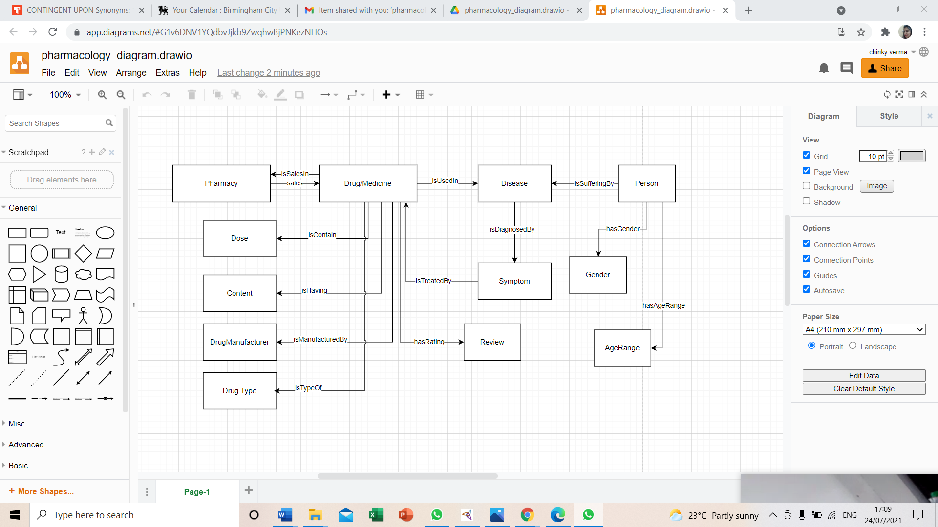
Figure 3: Pharmacology E-R Diagram

From entity-relationship diagram, Pharmacology ontology triples are following:
- Person is suffering from disease.
- Disease is diagnosed by symptoms.
- Drug or medicine is used in diseases.
- Symptom is treated by Drug.
- Drug or Medicine is containing dose.
- Drug or Medicine is having Drug content.
- Drug or Medicine is manufactured by drug manufacturer.
- Drug or Medicine is type of drug types.
- Drug has rating as Review.
- Drug is sale in Pharmacy.

6. Ontology Documentation

Pharmacology is a medical science that deals with the discovery, chemistry, effects, uses and manufacture of drugs covering all the symptom details and disease information.
Basic of Ontology:
As of late the advancement of ontologies express proper determinations of the relationships in the area and relationships among them (R.Gruber, 1993). It has been moving from the domain of Artificial-Intelligence research centres to the work areas of space specialists. Ontology is collection of vocabulary and infer rules (bravo, 2019). Ontology contains data properties, classes, entities and individuals along with relations. Ontologies are regularly updated on the World-Wide Web.
Artificial-Intelligence is a process of enormous research works and its composing contains various implications. From that description behind this guide, an ontology is a conventional express depiction of thoughts in a space of talk (classes (a portion of the time called thoughts)), properties of each thought portraying various features and qualities of the thought (openings (once in a while called employments or properties)), and constraints on spaces (angles (every so often called activity confinements)). A great deal with individual events of classes includes a database. Truth be told, there is a practically insignificant distinction which closes and the data base begins.

6.1 Methodology for Pharmacology ontology development
Firstly, Pharmacology drug ontology data is explained in various stages. Then, Plethora of classes and subclasses is created at a subsequent stage. Recognizing the concept along with the information properties among the classes and the sub classes are developed in the third stage moreover the range and the area for these classes and subclasses is generated at the fourth stage. Even the remarks for clarifications of the areas are added to the properties and classes. Formation of the classes, its epitomes and the setting their data properties (information and item) is the fifth stage. Sixth stage cover ups the consistency check for which different inbuilt reasoners like pellet can be utilized. Furthermore, comes the seventh stage, which spares the ontology in RDF/OWL design. Finally, the prototype ontology is developed for the Computer Science and Medical domain having more than 160Rdf triples in pharmacology ontology (RitikaBansal & , n.d.).
Pharmacology drug ontology is conveniently used in numerous areas especially for the biomedical space. One of the most unpredictable space of human information and there is an expanding requirement for organizing and formalizing this information (Andre Lamy & , n.d.)
Ontologies have been utilized in numerous areas, and specifically the biomedical space. Today it is one of the most unpredictable spaces of Human information, and there is an expanding requirement for organizing and formalizing this information. (Lamy, 2017)
Protégé can be run as an independent application or through a Protégé customer in correspondence with a remote server (the last is especially helpful for community-oriented philosophy improvement). At the point when the Protégé work area application is propelled, the client can make another metaphysics, open a current philosophy, or import a drug ontology from an assortment of configurations. (Rubin & , 2007) Protégé makes a venture document that records, show related data and the area of the drug ontology source record; the undertaking record improves the way toward reviving ontologies, and it keeps up client GUI customizations.

6.2 Classes
Classes like drug, disease, symptoms, rating and many more plays an inevitable role in this drug ontologies. Classes illustrates the logic in different areas for instance, a class of wines speaks to all wines therefore Explicit wines occurrences in this class. Pharmacology ontology contains drug, disease, symptom, rating, gender, age, pharmacy drug content, drug type and drug dose kind of information.
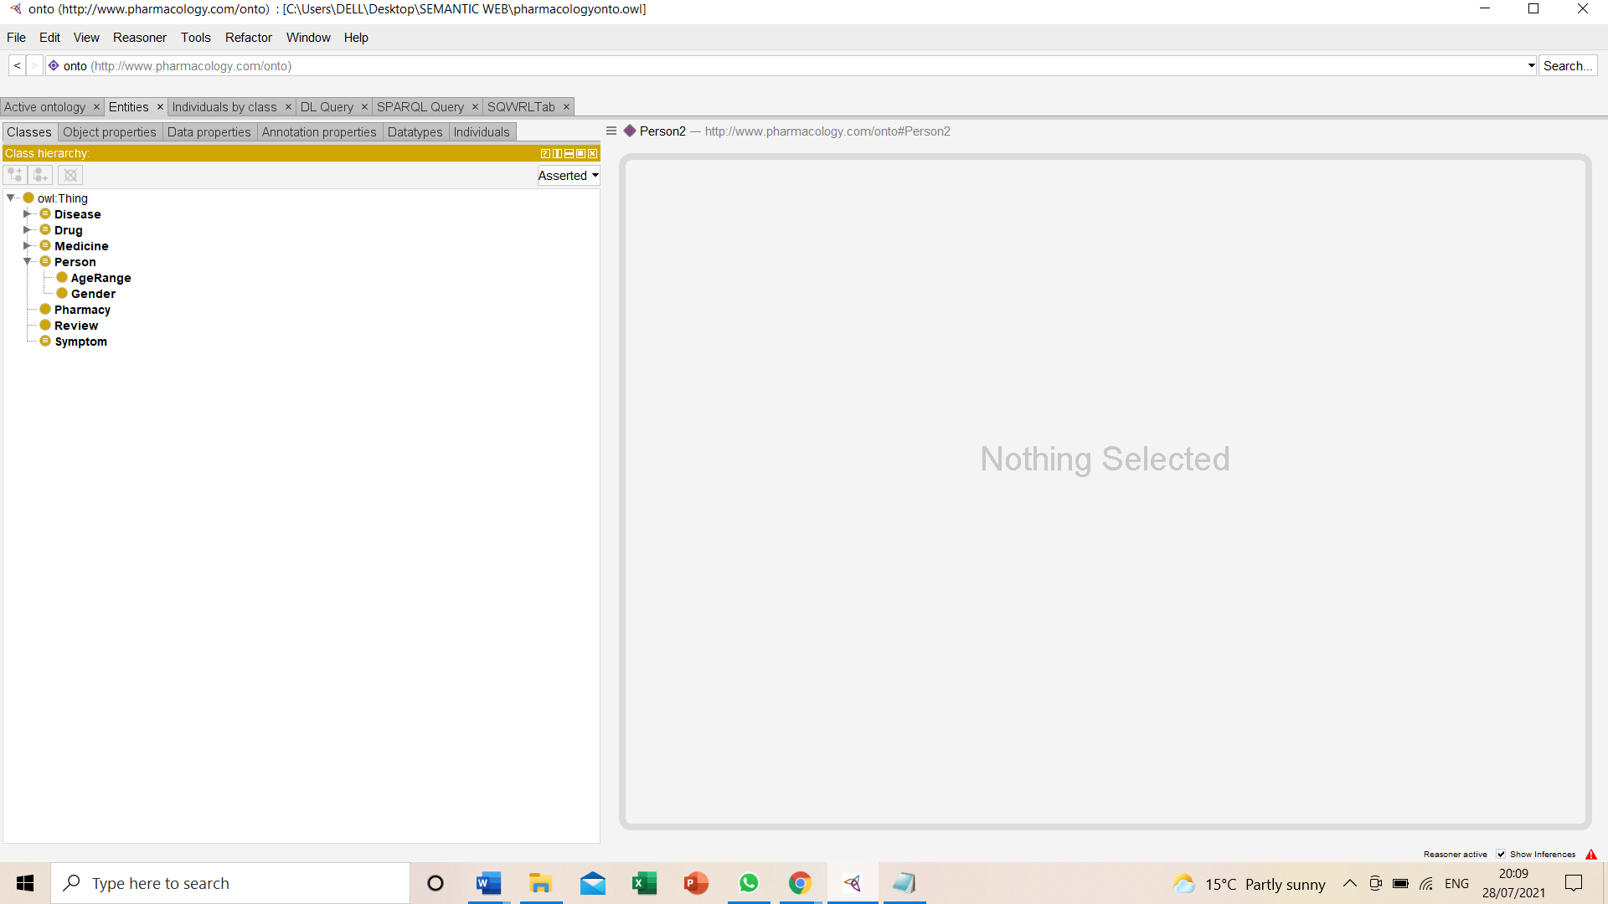
Figure 4: Classes of pharmacology ontology

6.3 Object Properties
The Object Property qualities declares the attributes for selected object property of pharmacology drug ontology. Attributes will appear in the checkboxes. Pharmacology ontology contain different characteristic functional property, Inverse functional property, Transitive property, symmetric property, Asymmetric property, Reflexive property and Irreflexive property. There are object properties in drug ontology like hasAageRange, genderType, isContain, hasDose and many more. Moreover, object properties of this pharmacology contain abandon of relationships which are added between the classes and depicts the relationship between an individual to individual.

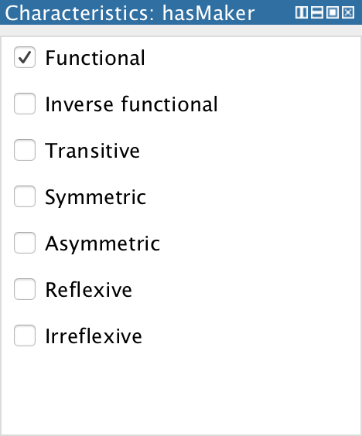
Figure5: Characteristics of Object Properties

Researcher has assigned some relationships between source class to destination class. Researcher has implemented object properties in protégé its snapshot is given figures. Here, researcher take object properties like IsContain, IsDiagnosedBy, IsHaving, IsManufacurerBy, IsTypeOf, and IsUsedIn. These object properties are relation between source classes and destination classes. This is known as predicate.
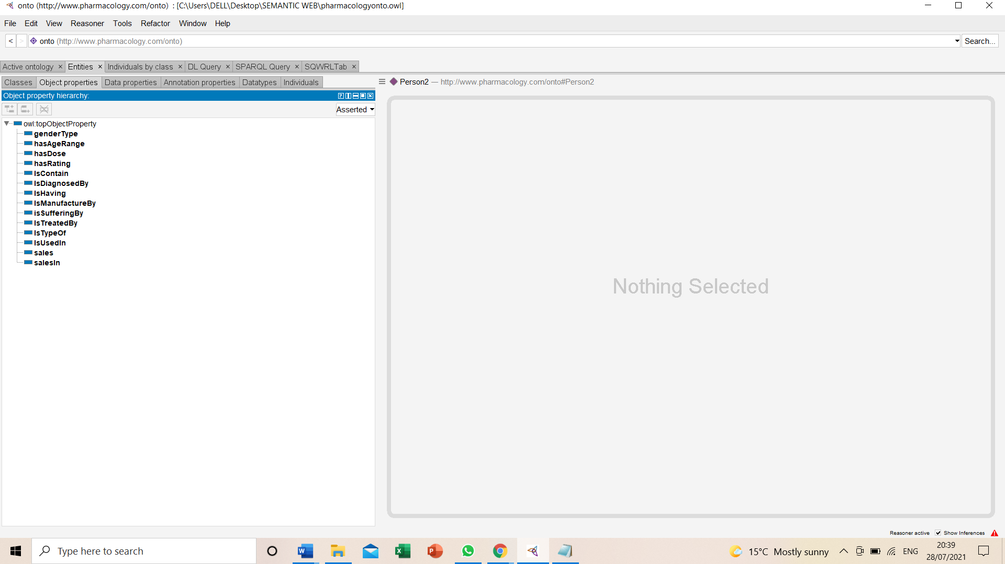
Figure 6: Object properties of pharmacology ontology

6.4 Data Properties:
The data property has levels of leadership which reveals the announced and assembled data property movements. The announced data property movement is obviously recognizable. The expressed information property chain is the basic course in Protégé. It is accessible as a centre point in tree form, identifying the information properties. A child centre point addresses is an information property having sub-property of the property addressed by the parent centre.
- Drug contains data properties like DrugId, DrugName.
- Disease contains data properties like DiseaseId, DiseaseLatinName, DiseaseShortName, Description.
- Symptom contains data properties like SymptomId, SymptomName, Symptom Description.
- Dose contains DoseId, DoseShortName,DoseDescription.
- Dose Manufacturer contains ManufacturerId, ManufacturerName, Description.
- Dose Type contains DrugTypeId, DrugTypeName.

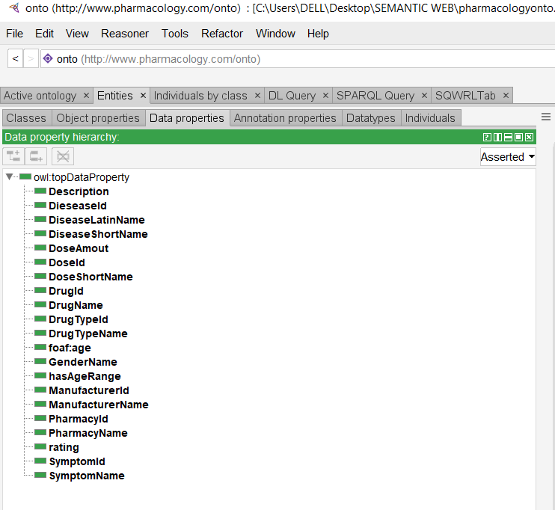
Figure 7 Data property of Pharmacology ontology

6.5 Individual means value of ontology:
Individuals (instances) are the fundamental, "ground level" segments of this drug ontology. (A.Arcos-Novillo, 2017) The individuals in a metaphysics may fuse strong things, for instance, people, animals, tables, vehicles, particles, and planets, similarly as special individuals, for instance, numbers and words.

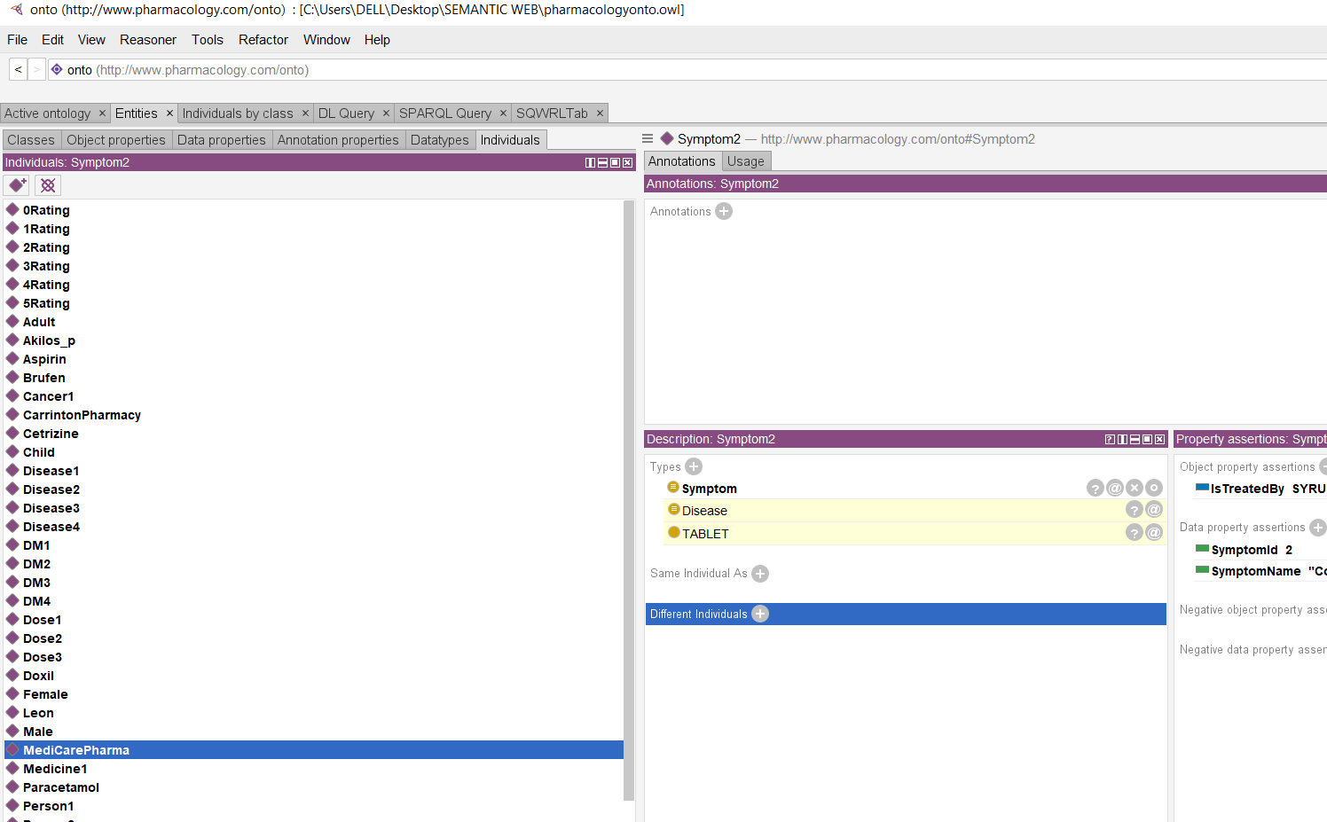
Figure 8: Individual of pharmacology ontology

6.6 Pharmacology Drug Ontology Class diagram among other classes: There is a main class Thing and all the classes of this pharmacology drug ontology is sub classes of OWL:Thing class which can be figured out as follows:

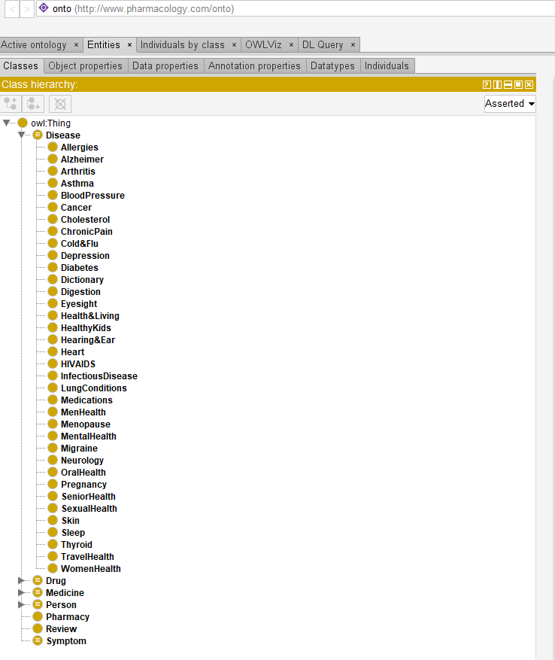
Figure9: Subclasses of Disease in pharmacology ontology

Similarly there are enormous medicines in this drug ontology as the required by each and every disease mentioned according to the symptoms.

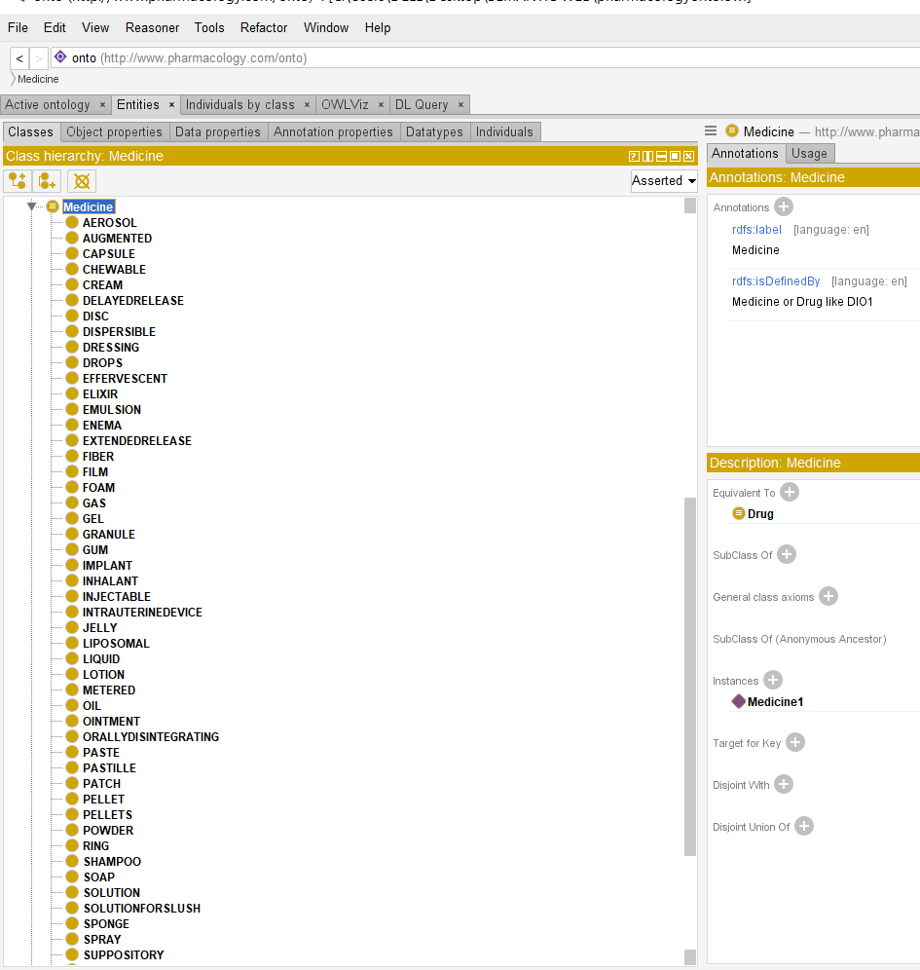
Figure 10: Subclasses of Medicine in pharmacology ontology

Some more figures of this drug ontology cane be figured out by using onto graph:

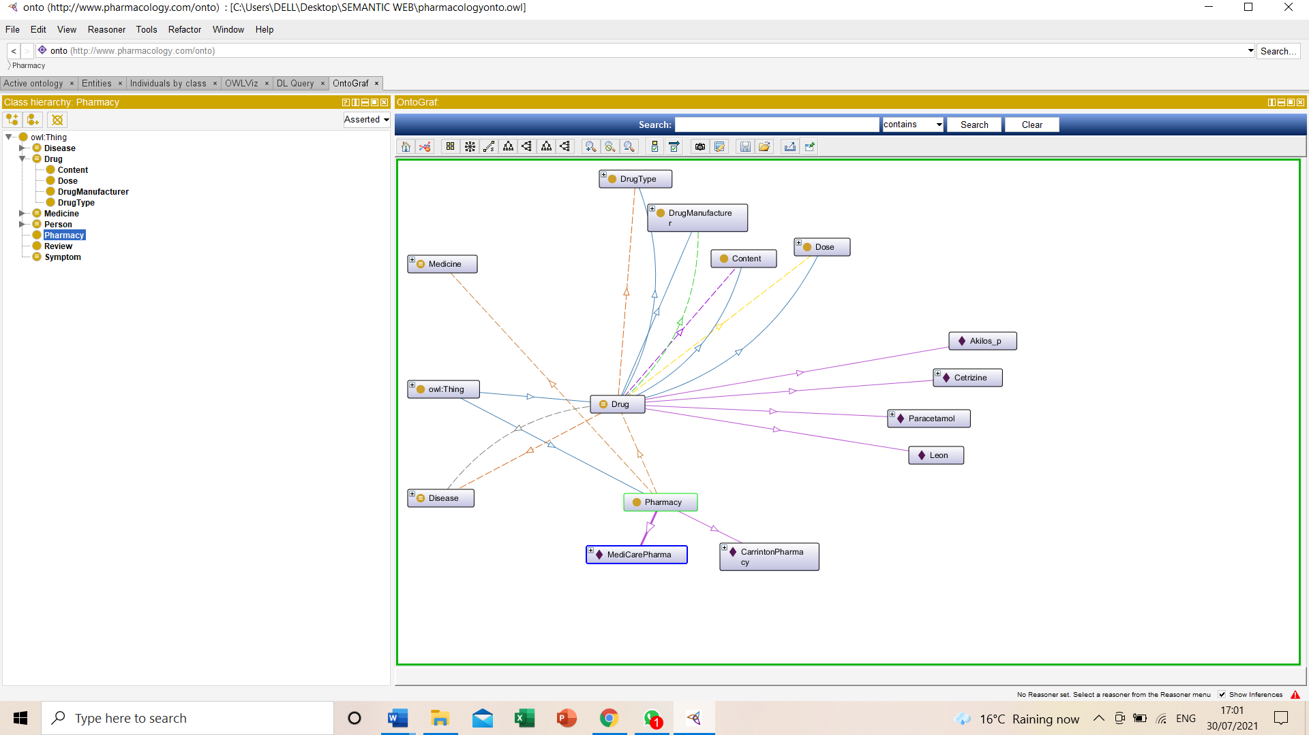

Figure11: Subclasses of Drug and Pharmacy in pharmacology ontology

Review also plays an important role in this pharmacology drug ontology as it represents the rating level from 0-5 about the tablets and other medicines which are demanded by the persons suferring from the diseases having different symptoms.

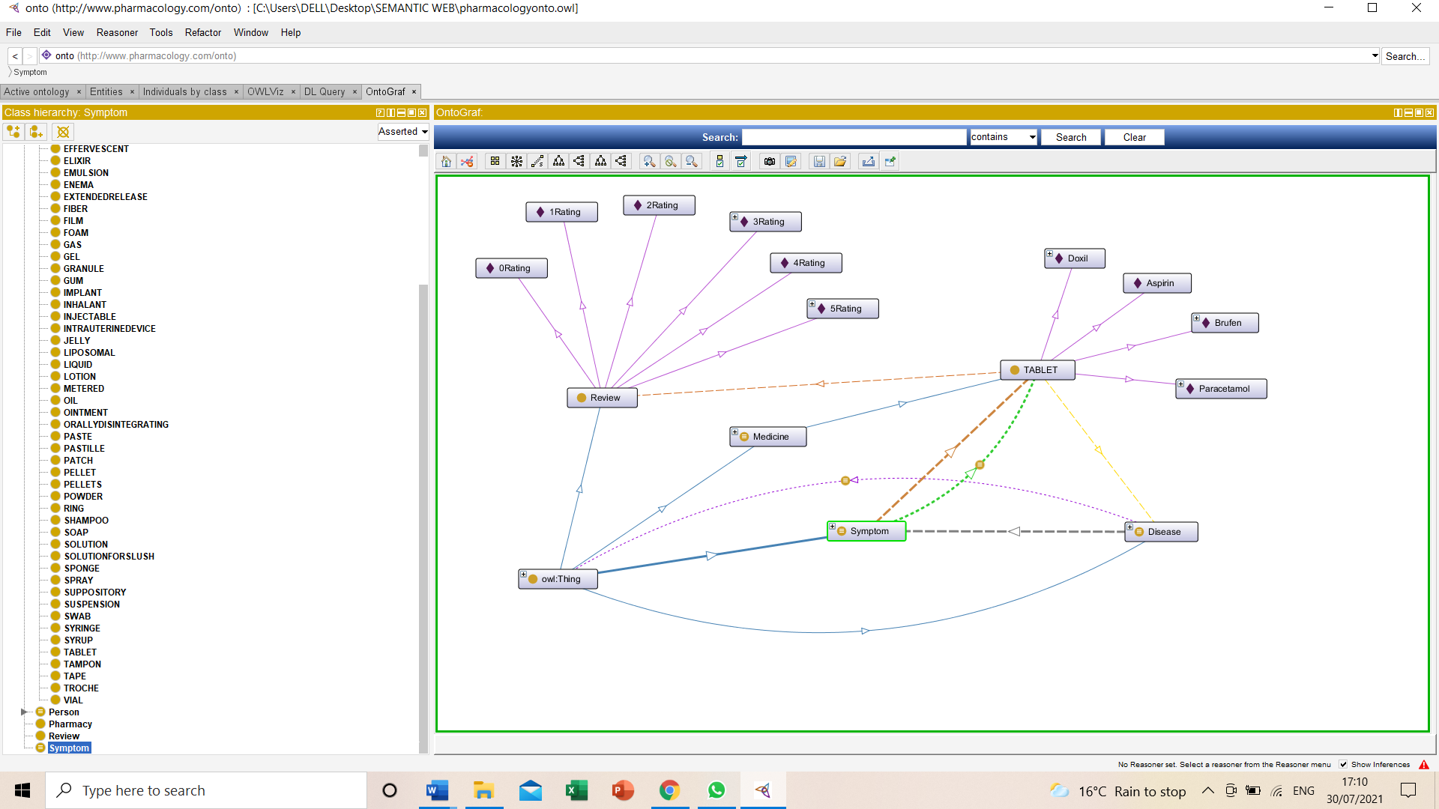

Figure12: Subclasses of Review in pharmacology ontology

7. Example of Usage

In this technical era, growth for data in pharmaceutical sector is upsurging like a bonfire which has created abundant of technical threat of data mining like drugs usage according to the symptoms and disease. Pharmacology drug ontology has shown plethora of epitomes to clear its concept for selecting the best drugs according to the disease and symptoms. Having consolidation towards the resilience of RDF and the articulation of SPARQL yields a strong contrivance to the designed model, assimilate the query data has been created. However, these components are required for the fruition of the SPARQL queries. In this drug ontology, myriad semantics for RDF and SPARQL to analyse complexity of this drug ontology along with the constructing of SPARQL queries has been designed. (AntonisLoizou, March,2015) Pharmacology Drug ontology has enormous examples described below in the form of queries.

SPARQL QUERIES

- To display a Person detail like disease name, gender and age range?

In this SPARQL query we are finding a person who is suffering from any disease, to find about the disease and person’s gender along with age range he or she have like adult, teenager, or child.

PREFIX rdf: <http://www.w3.org/1999/02/22-rdf-syntax-ns#>
PREFIX owl: <http://www.w3.org/2002/07/owl#>
PREFIX rdfs: <http://www.w3.org/2000/01/rdf-schema#>
PREFIX xsd: <http://www.w3.org/2001/XMLSchema#>
PREFIX test:<http://www.pharmacology.com/onto#>
PREFIX foaf: <http://xmlns.com/foaf/0.1/>

SELECT ?indv ?d ?dname ?gender ?agerange
WHERE
{
?indv a foaf:Person .
?indv test:isSufferingBy ?d .
?d test:DiseaseLatinName ?dname .
?indv test:genderType ?gender .
?indv test:hasAgeRange ?agerange .
}

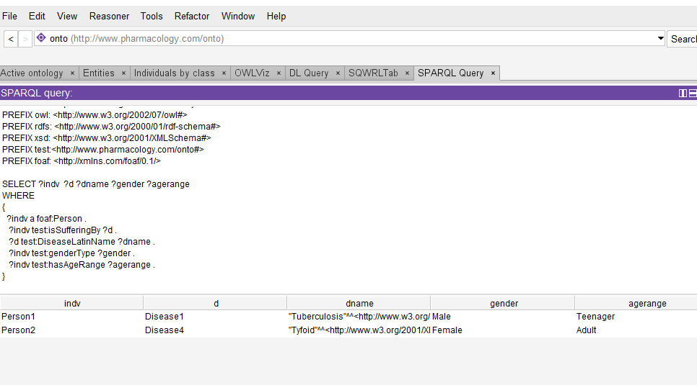

2 To display about the Pharmacy selling the particular medicine?

This query will find the pharmacy name which sales the particular medicine. For example, like cancer disease medicine docile are sold on one particular pharmacy that is Medicare Pharmacy.

PREFIX rdf: <http://www.w3.org/1999/02/22-rdf-syntax-ns#>
PREFIX owl: <http://www.w3.org/2002/07/owl#>
PREFIX rdfs: <http://www.w3.org/2000/01/rdf-schema#>
PREFIX xsd: <http://www.w3.org/2001/XMLSchema#>
PREFIX test:<http://www.pharmacology.com/onto#>
PREFIX foaf: <http://xmlns.com/foaf/0.1/>

SELECT ?ind ?medi
WHERE
{
?ind a test:Pharmacy .
?ind test:sales ?medi .
}
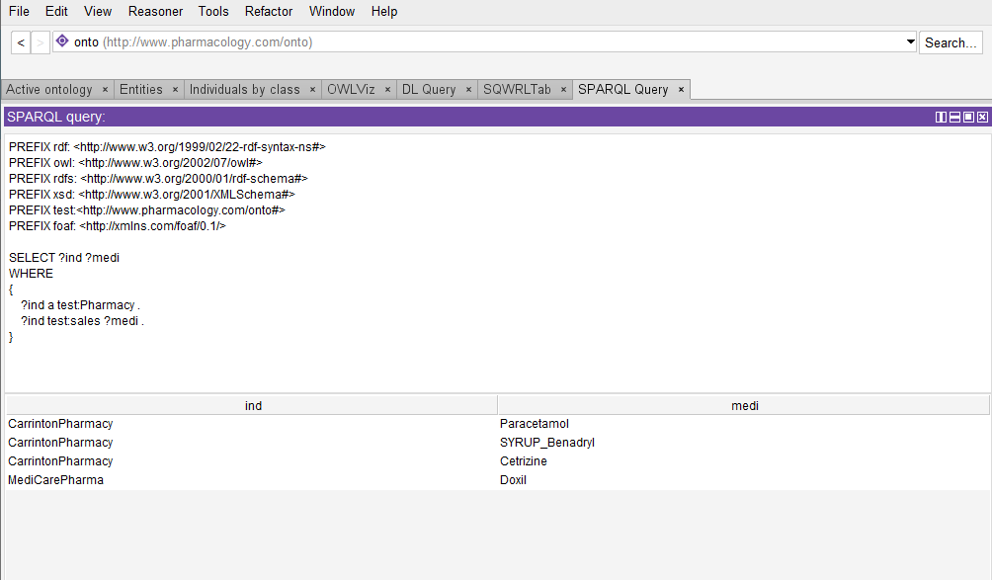
3 To Search the disease according to the symptoms?
This query is used to find disease with respect to symptom. The result is showing symptom and disease.
prefix owl: <http://www.w3.org/2002/07/owl#>
prefix rdfs: <http://www.w3.org/2000/01/rdf-schema#>
PREFIX test:<http://www.pharmacology.com/onto#>
Select?sname ?dname
where
{
?x a test:Symptom .
?x test:SymptomId ?id .
?x test:SymptomName ?sname .
?y a test:Disease .
?y test:DiseaseLatinName ?dname .
?y test:IsDiagnosedBy ?x .
Filter regex(?sname,"headache","i")
}
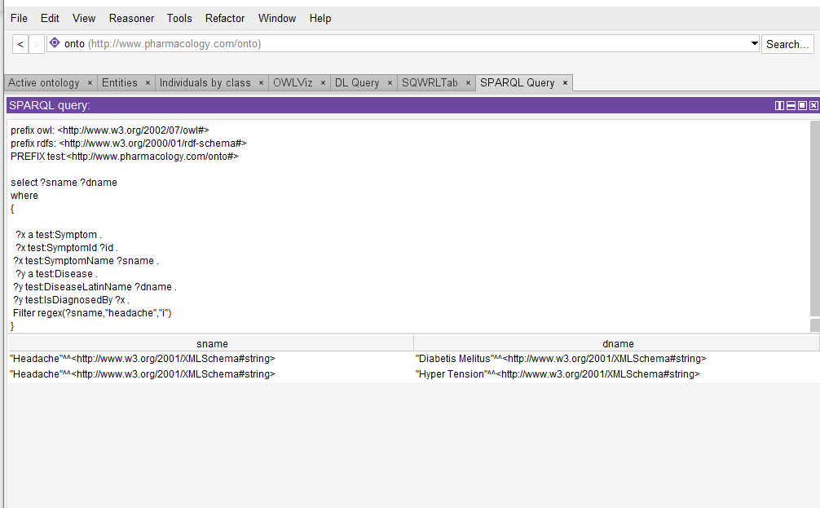

4 To Check Medicine detail in ontology using Ask query?
Using ASK query we are finding the medicine details in pharmacology drug ontology. though ASK query is used to check the availability of the medicine by true /flase.

prefix owl: <http://www.w3.org/2002/07/owl#>
prefix rdfs: <http://www.w3.org/2000/01/rdf-schema#>
PREFIX test:<http://www.pharmacology.com/onto#>

ASK
where
{
?x a test:Medicine .
?x test:DrugName ?drugname .
}
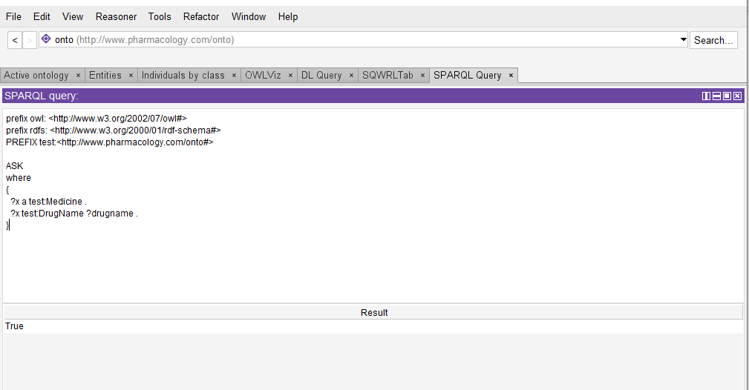

5 To display Dose short name in the ontology?
This query will find the short name of Dose and gives the dose detail in Ml or Mg.

prefix owl: <http://www.w3.org/2002/07/owl#>
prefix rdfs: <http://www.w3.org/2000/01/rdf-schema#>
PREFIX test:<http://www.pharmacology.com/onto#>

select ?x ?doseshortname
where
{
?x a test:Dose .
?x test:DoseShortName ?doseshortname .
}
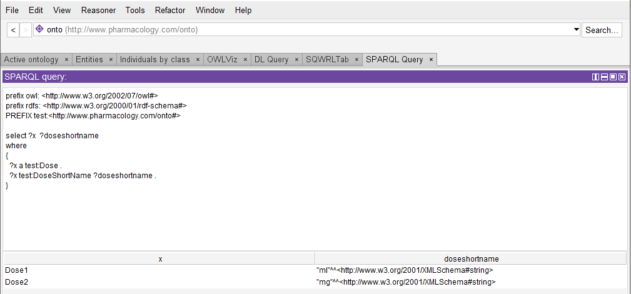

6 To display Drug Manufacturer company name?
This query will retrieve the result about the name of drug manufacturer company like Cipla, Mankind, Zydus etc.

prefix owl: <http://www.w3.org/2002/07/owl#>
prefix rdfs: <http://www.w3.org/2000/01/rdf-schema#>
PREFIX test:<http://www.pharmacology.com/onto#>
select ?x ?mname
where
{
?x a test:DrugManufacturer .
?x test:ManufacturerName ?mname
}
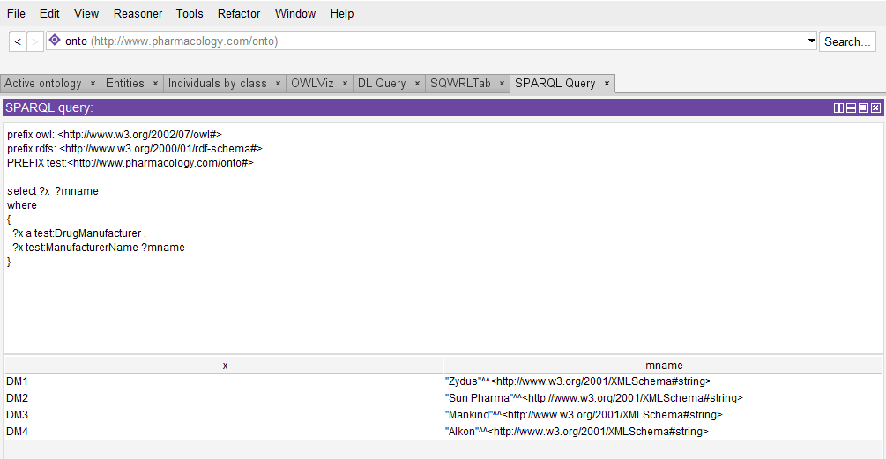

8.Evaluation of Implemented Approach

8.1 DL queries
The description logic of technology is primarily characterized to develop complicated approaches and aspects. DL is a suite of explicit conceptualized languages convenient for knowledge delegation systems. DL is perfect to inference within the domain of concern and provides inference support to semantic web. Promoters for software on internet can develops axioms based on subsequent inferences as explained in it. It is a so-called truth statement written by the developer of terms related to the concept of axioms. Description logic is basically used for knowledge representation. (Pandey & , 2012) Knowledge delegation systems need to create query answers based on the logic of reasoning. Therefore, DL must be expressive so that Axioms can be defined to support proper and reliable reasoning, but DL complexity tends to increase as expressiveness increases.

1. To display disease which is diagnosed by some symptoms?
In this query we have diagnose diseases along with symptoms where the subclasses and the instance has been displayed by applying

Disease and(IsDiagnosedBy some Symptom)

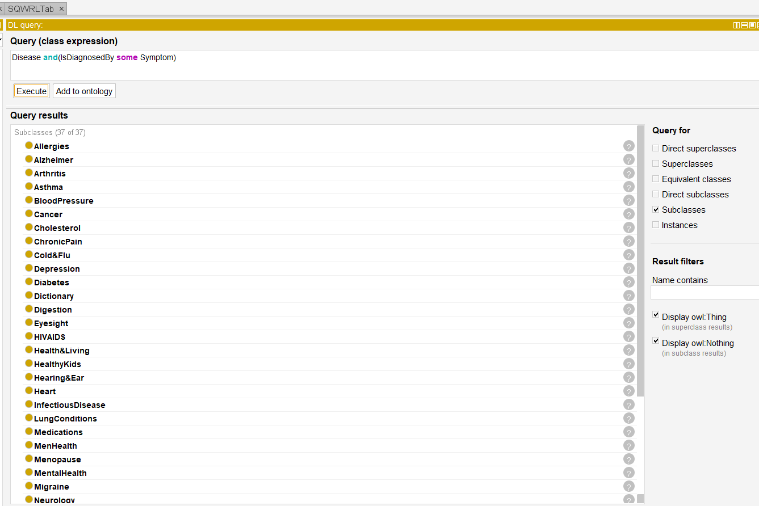

Instances will be displayed in this figure after diagnosing the diseases.

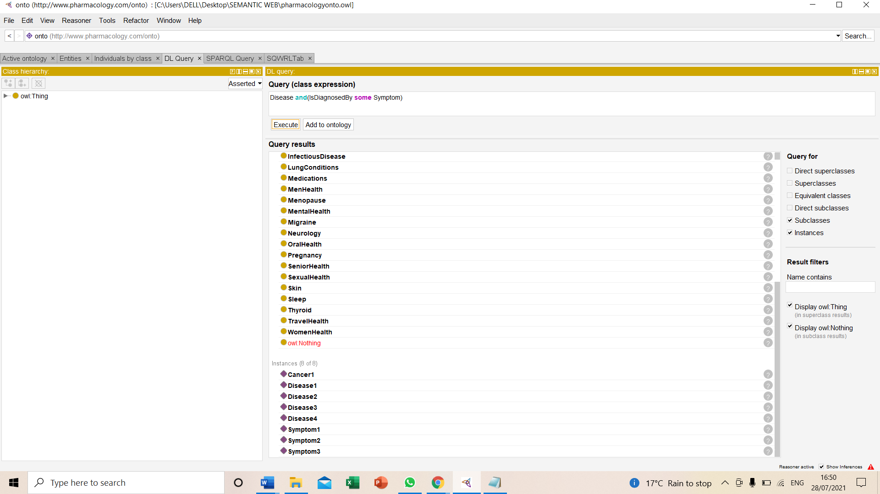

2. To display Pharmacy sale of some medicine ?

In this query sale of medicines has been displayed by the different pharmacies. It will show the detail of all the pharmacies selling slot for the medicines.
Pharmacy and(sales some Medicine)

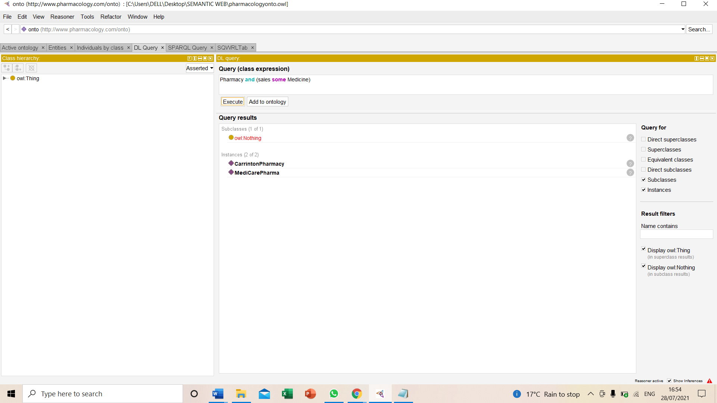

3. To display information about the person who has minimum one symptom and can be treated by medicines?
This query will reveal the information about the medicines needed to cure the symptoms of the person either male or female .
Person or(IsTreatedBy min 1 Symptom)
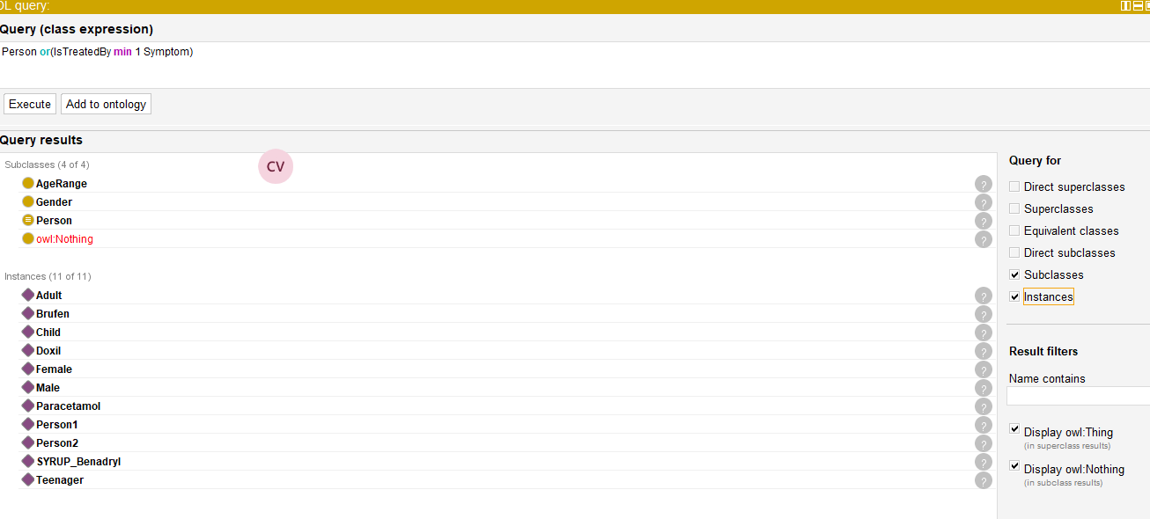
4. To display the reviews about the drugs in Dl query ?
This query will display all the rating only by writing only review on the Dl query tap ,all the instances as rating levels from 0 – 5 will appear.
Review

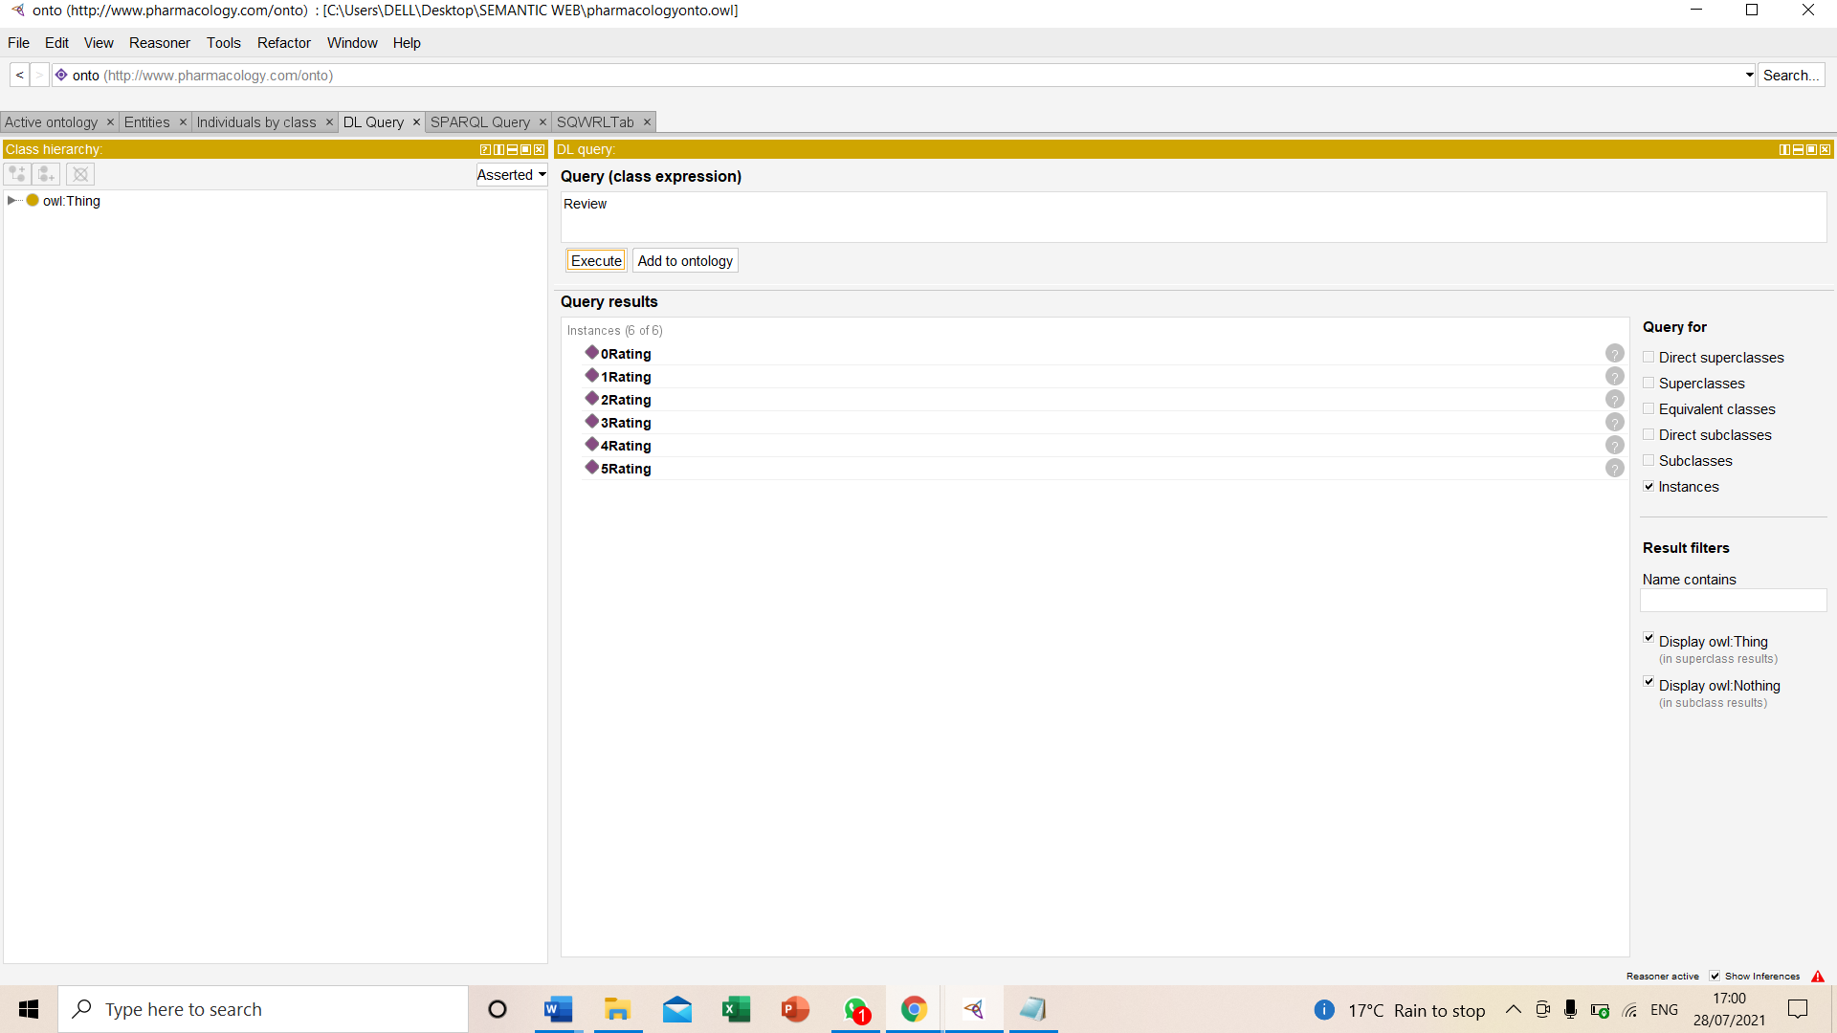

5. To display disease short name?
This query will reveal the information about the disease short name by setting the value it will show the instance as disease1.

DiseaseShortName value”TB”

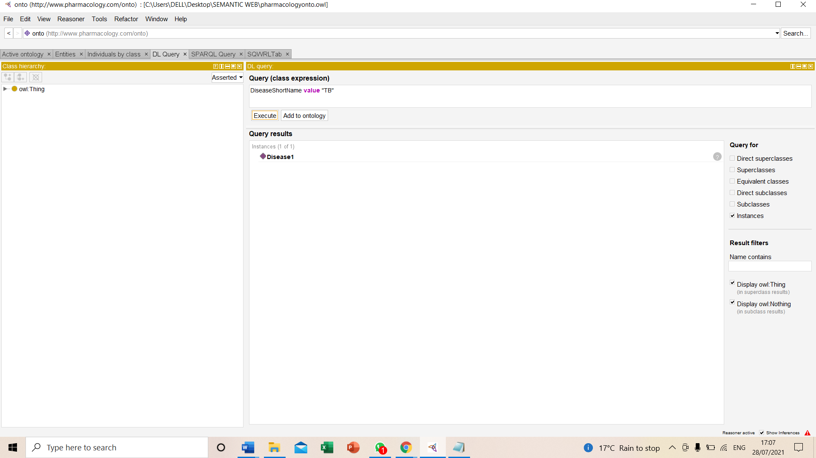

6. To display the gender type of the person ?
This query will show the gender type of the person like by adding the value male / female it will reveal the instance as Person1 is male or Person2 is female.
Gender or(genderType value Male)
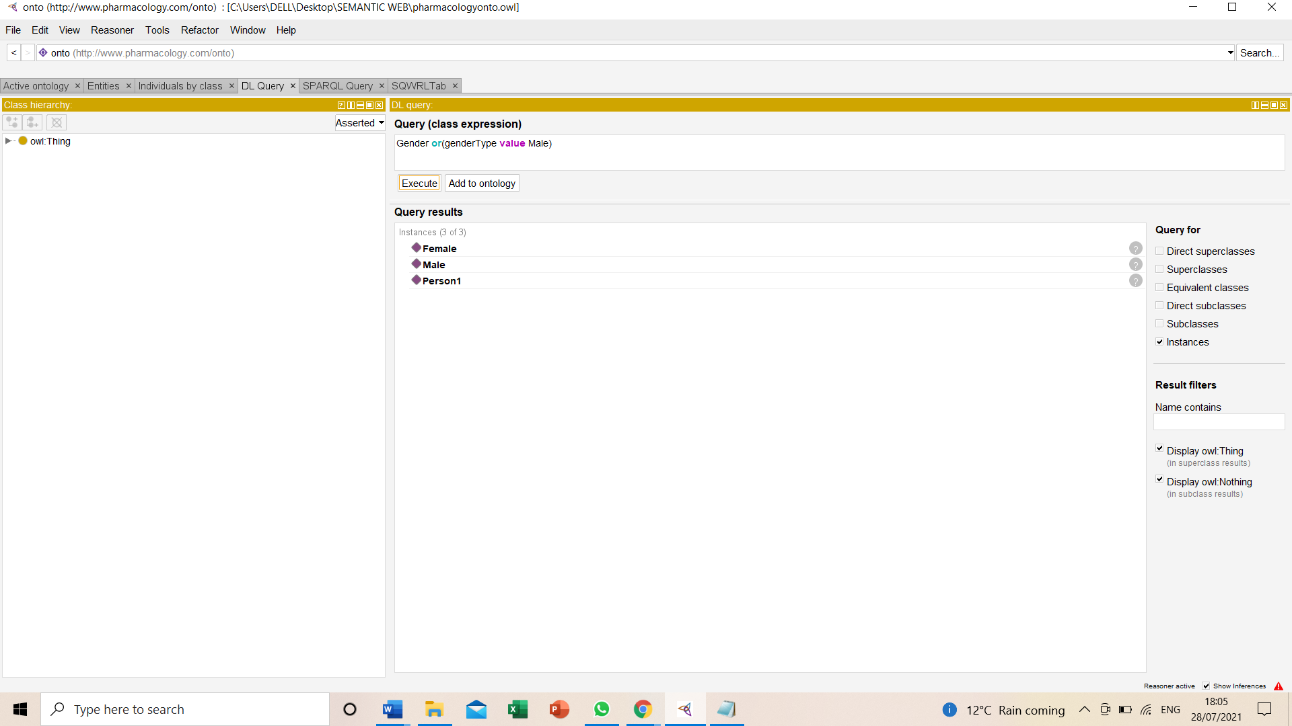

8.2 SWRL Functional Rules
SWRL (Semantic Web Rule Language) is an OWL Description logic ontology articulation that concede for additional rule representation. SWRL was intended as an axiom language. SWRL is totally an OWL protégé, all rules are represented by OWL concepts (classes, attributes, individuals, literals). The SWRL is an evolution aura for processing SWRL functional rules in Protege. It buttresses the annotation and execution of SWRL rules. Moreover, also implements the mechanism enabling the interoperability with various test engines and integration of methods which are defined by the users and libraries used in these rules. Though the operators that can be used to effectively convert these SWRLs in the query language along with several built-in libraries including collection of mathematical, string, and temporal operators are required. (Musen, 2017) This language yields an elementary but authoritative approach to excerpt information on OWL ontology.
There are number of Functional rules implemented in this Pharmacology Drug Ontology Each and every rule has represented some information from the ontology like drug name, gender, pharmacy name and many more. All these rules described in the ontology are shown in the figure below:

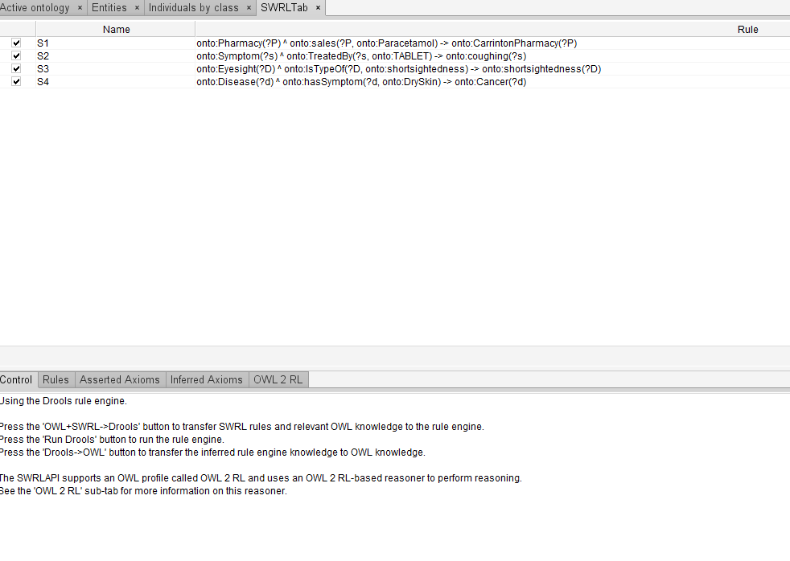

1.To display Which Pharmacy sales the particular Medicine?
In this SWRL query, pharmacy name will be named which sales the Paracetamol Medicine .
onto:Pharmacy(?P) ^ onto:sales(?P, onto:Paracetamol) -> onto:CarrintonPharmacy(?P)

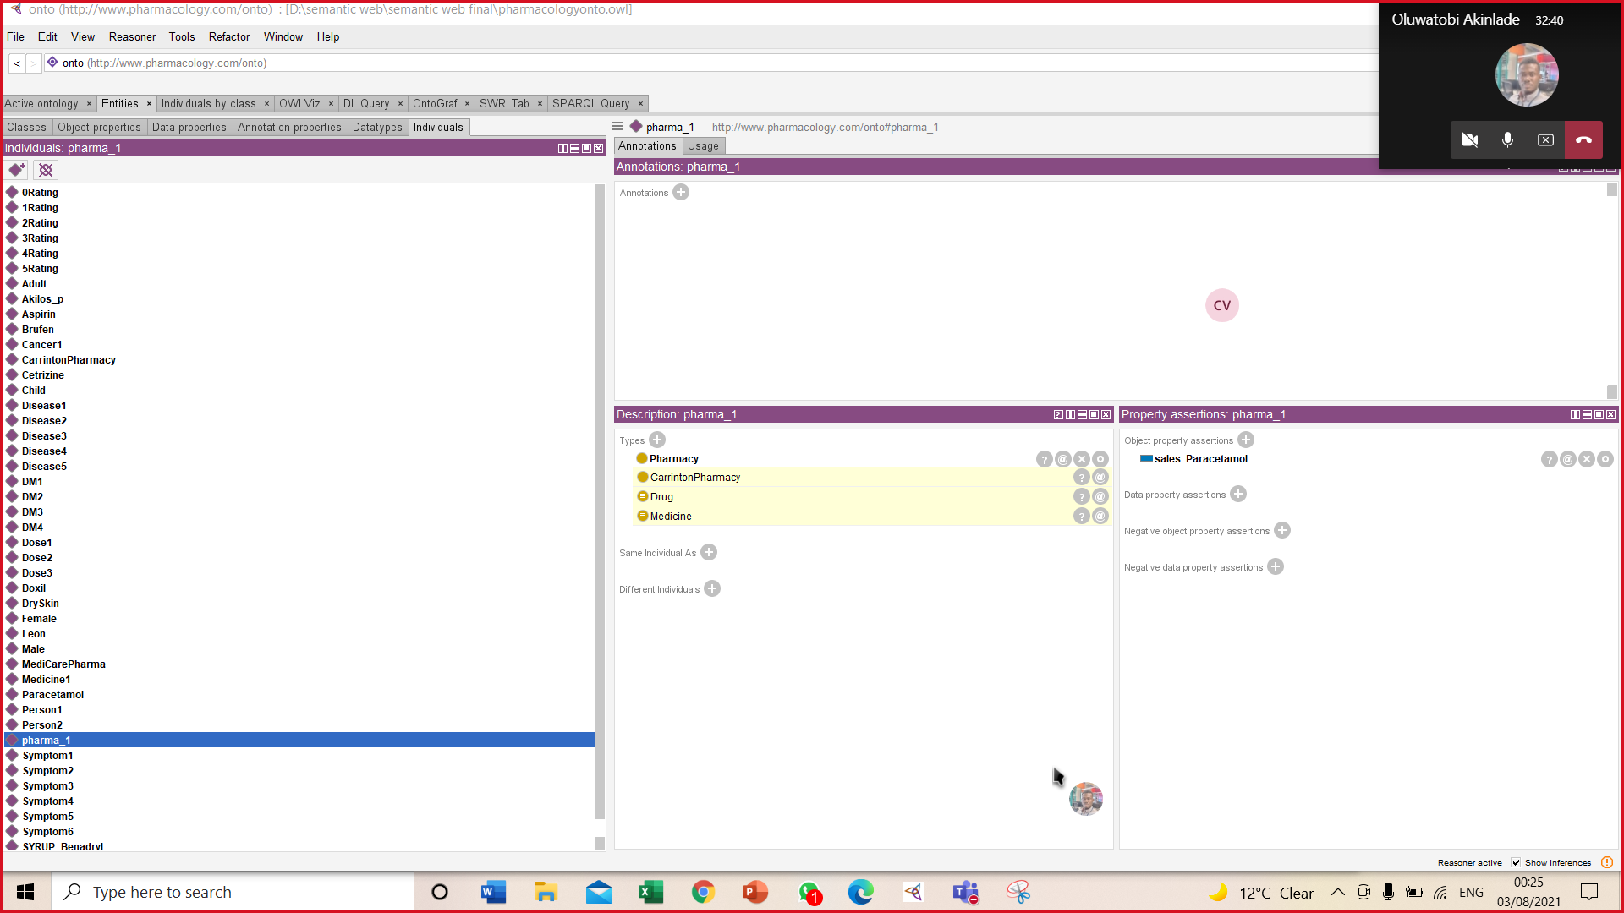

2.To display the details about Symptom which will be treated by which Medicine?
In this rule reveals that Symptom7 which is coughing in the pharamacology ontology is treated by Tablet
onto:Symptom(?s) ^ onto:TreatedBy(?s, onto:TABLET) -> onto:coughing(?s)
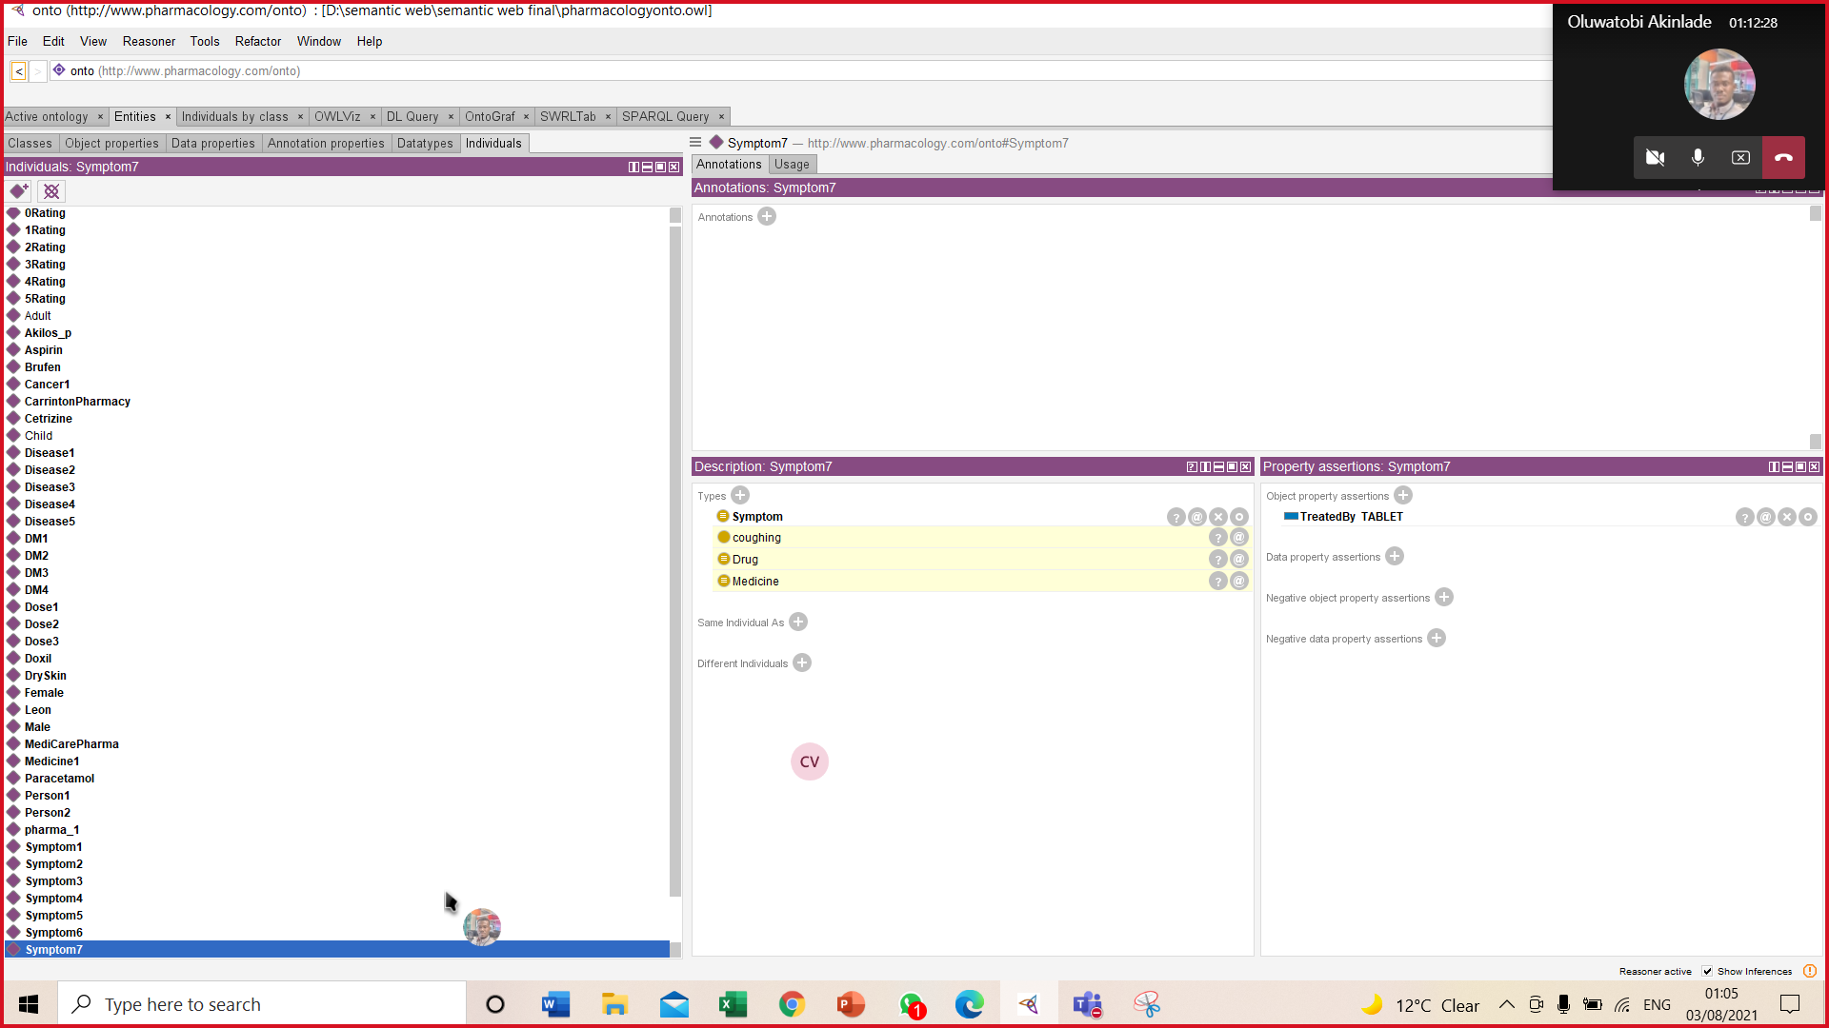

3.To display disease which is related to EyeDeficiency?
In this SWRL rule shortsightedness is a type of Eyesight
onto:Eyesight(?D) ^ onto:IsTypeOf(?D, onto:shortsightedness) -> onto:shortsightedness(?D)

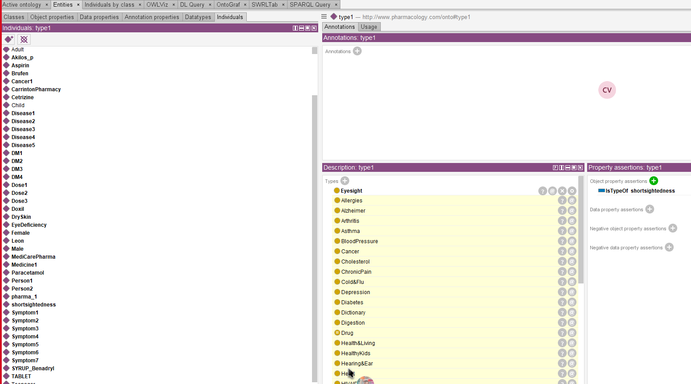

4.To display the diease which has Symptoms for DrySkin?
In this functional rule disease having symptom of dry skin will disolay the disease name cancer.
onto:Disease(?d) ^ onto:hasSymptom(?d, onto:DrySkin) -> onto:Cancer(?d)

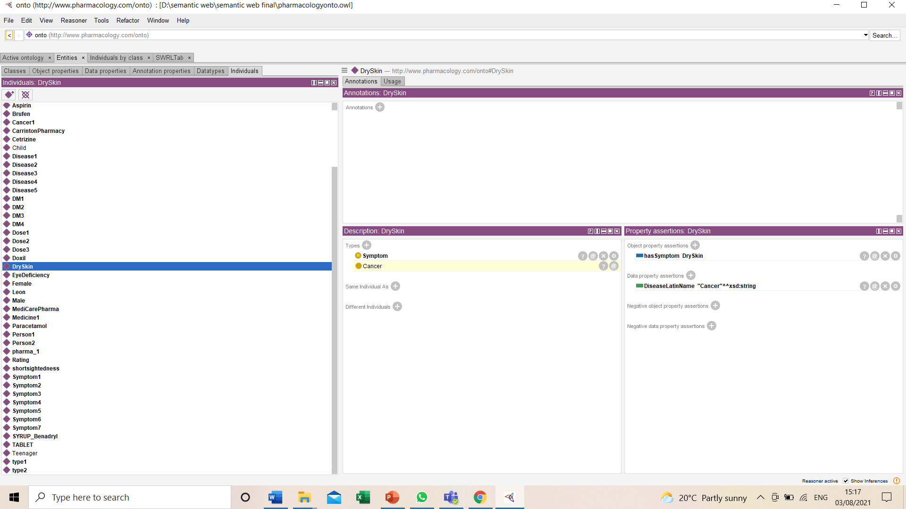

9.Conculsion
To recapitulate, this research will develop a pharmacology drug ontology in which plethora of diseases are recognised by their symptoms for which abundant of drugs, depending on the gender and age of the person are diagnosed. This study describes the drugs in detail with its content, type, manufacturer, dose etc which is further sold in the pharmacy. Evaluation of this ontology also reveals the information about the reviews which plays an inevitable role in this pharmacology drug methodology as it gives rating to the drugs which is more convenient for the future use. The paramount acquire for this research is to discover dimensions about the drugs regarding there best usage according to the symptoms (TabbasumNaz & , sept,2020). This pharmacology drug ontology was evaluated through the queries and the answers were obtained to appropriateness of interrogations assigned in the inaugural phases of the methodology adequate to covenant the work achievement by answering them as it was designed (Reyes-Pe˜na, 2020). Therefore, OWL and Semantic web technologies like numerous SPARQL, DL queries and SWRL rules were implemented to extract the data from the ontology along with RDFs schema is utilised which is fortuitous for emerging drug recommendation cosmology.

10.Future Work
This ontology assumption will be addressed in future, automatic drug cosmology-based tools can be promoted for remote prescriptions and telemedicine in smart health aura (TabbasumNaz & , sept,2020). Inadequacy with myriad illnesses and drug doses due to time constraints, are the worse cases for which this drug ontology can be conducive (Hanna, 2013). Though it is critical to bridge medication concede to symptoms, therefore this pharmacology drug methodology is enriched with generality, interactions, contraindications and precautions along with the non -ontological resources that effects the scope of this model for drugs. Moreover, this ontology indicates the classification criteria for active pharmaceutical ingredients and can be used by international biomedical students, researches and pharmaceutical organisations. Further, having immense medical data cane give more effectiveness to the ontology. More homeopathic and allopathic drug details can be added this ontology to enhance this topic widely.

References
- A.Arcos-Novillo, D., 2017. Development of an additive manufacturing technology scenario for opportunity identification—The case of Mexico.
- Andre Lamy & J. A., n.d. Journal of the American College of Cardiology.
- AntonisLoizou, March,2015. On the formulation of performant SPARQL queries. Journal of Web Semantics, Volume 13.
- Arbabi, M., 2018. Adaptation of the Pharmacological Management of Delirium in ICU Patients in Iran: Introduction and Definition.
- Bona, B. & W. R. H., 2019. Enhancing the drug ontology with semantically-rich representations of National Drug Codes and RxNorm unique concept identifiers.
- brAVO, 2019. Pharmacological management of Dysautonomia following traumatic brain injury.
- Brickley, D., 2014. FOAF.
- Chahal, S. & N. G., 2021. Factors Associated with Poor Antiepileptic Drugs Adherence in Below Poverty Line Persons with Epilepsy: A Cross-Sectional Study.
- Chittella, R. S., 2019. Leveraging Schema Information For Improved Knowledge Graph Navigation.
- Hanna, J., 2013. Building a drug ontology based on RxNorm and other sources.
- Melissa Conrad Stöppler, M., 2020. Medical Definition of Pharmacology.
- Musen, M., 2017. Querying the Semantic Web with SWRL.
- Pandey, R. & S. K. S., 2012. Description Logic based Quantifier Restriction and. International Journal of Computer Applications (0975 – 8887), Volume 42.
- Protege, 2020.
- R.Gruber, T., 1993. A translation approach to portable ontology specifications. Volume https://doi.org/10.1006/knac.1993.1008.
- Reyes-Pe˜na, C., 2020. Drug Ontology for the Public Mexican Health.
- RitikaBansal & S., n.d. Design and development of semantic web-based system for computer science domain-specific information retrieval. 2016.
- Rubin, D. L. & . N. F. N., 2007. Protégé: A Tool for Managing and Using Terminology in Radiology Applications.
- Sharp, M. E., 2017. Toward a comprehensive drug ontology: extraction of drug-indication relations from diverse information sources. Journal of Biomedical Semantics.
- Siricharoen, D. W. V., 2009. Ontology Modeling and Object Modeling in Software Engineering. International Journal of Software Engineering and Its Applications.
- society, B. P., 2020. Pharmacology.
- SonalChawla & R., 2016. Design and development of semantic web-based system for computer science domain-specific information retrieval.
- TabbasumNaz & M., sept,2020. Ontology-driven advanced drug-drug interaction. Computers & Electrical Engineering, Volume 86.
- W3C, H., 2010. HCLSIG/PharmaOntology/Resources.

